SOFTWARE REQUIREMENTS SPECIFICATION (SRS)
Prepared By: Team QUANTUM CODERS
Date: 31/07/2026
1. Title
AI-Powered Career Guidance Agent
2. Introduction
Purpose
The purpose of this project is to develop an AI-based career guidance system that helps students identify suitable career paths by analyzing their interests, skills, academic performance, and career goals.
Scope
The system will
- Analyze student profiles
- Assess skills and interests
- Recommend career options
- Suggest learning roadmap
- `Recommend certifications
- Recommend colleges/courses
- Track progress
3. Problem Statement
Many students choose careers without proper guidance.
They lack
- Career awareness
- Skill assessment
- Personalized recommendations
- Learning roadmap
4. Objectives
- Recommend suitable careers
- Analyze student interests
- Analyze academic performance
- Identify strengths and weaknesses
- Provide personalized learning plans
- Improve career decision making
5. Users
Student
- Register
- Login
- Complete profile
- Take career assessment
- View recommendations
- View roadmap
Career Counselor
- View student reports
- Monitor progress
Provide feedback
Admin
- Manage users
- Manage career database
- View analytics
- Update AI models
6. Functional Requirements
FR1 – User Registration  • Student signup  • Login & Password  FR2 – Student Profile  Store:  • Name  • Age  • Education  • School/College  • CGPA  • Skills  • Interests  • Hobbies  FR3 – Career Assessment  Collect:  • Interest questionnaire  • Personality assessment  • Skill assessment  • Aptitude scores  FR4 – AI Recommendation Engine  Recommend:  • Career paths  • Job roles  • Future demand  • Salary range  • Required skills | FR5 – Learning Plan  Suggest:  • Courses  • Certifications  FR6 – Skill Gap Analysis  Compare:  Current Skills  ↓  Required Skills  ↓  Missing Skills  FR7 – Dashboard  Display:  • Career score  • Skills  • Weak areas  • Recommended careers  • Progress chart  FR8 – Report Generation  Generate PDF report including:  • Career recommendations  • Learning roadmap  • Skill analysis

7. Non-Functional Requirements
Performance
- Response time < 3 seconds
Security
- Encrypted passwords
- Secure authentication
- Data privacy
9. Technologies
Category | Technologies
Frontend | • React.js • HTML • CSS • JavaScript
Backend | • Fast API (Supabase)
AI | • Python • Recommendation System
LLM
Database | Postgresql
Cloud | • Firebase• AWS

10. Software Requirements
- VS Code
- Python 3.12+
- Node.js
- Git
- GitHub
- MySQL
- Chrome
11. AI Module
Input
- Interests
- Skills
- CGPA
- Personality
- Aptitude
↓
AI Processing
↓
Output
- Career Recommendation
- Confidence Score
- Learning Plan
12. Use Cases
- Student registers
- Student fills profile
- AI analyzes profile
- AI recommends careers
- Student views roadmap
- Student tracks progress
13. Constraints
- Recommendation quality depends on available data.
- Initial AI model may require continuous improvement.
- Third-party APIs may have usage limits.
14. Deliverables
- Web Application
- AI Recommendation Engine
- Database
- Admin Dashboard
- Student Dashboard
- PDF Reports
- Source Code
- Documentation
- Presentation (PPT)
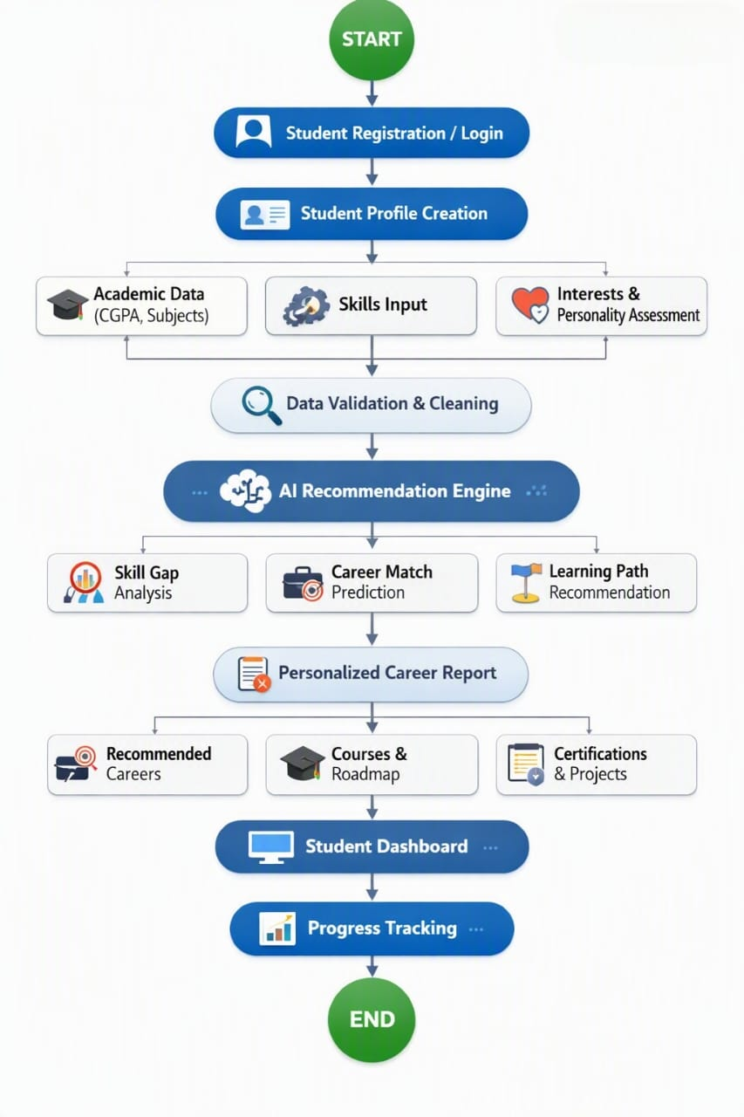

Conclusion
- The AI-Powered Career Guidance Agent provides an efficient and intelligent solution for helping students identify suitable career opportunities. By analyzing interests, skills, and academic performance, the system offers personalized career recommendations and structured learning plans. The proposed solution reduces the dependency on traditional career counseling, enables informed decision-making, and supports students in planning their future careers effectively.

